S5-L13 Cloud Watch Lab

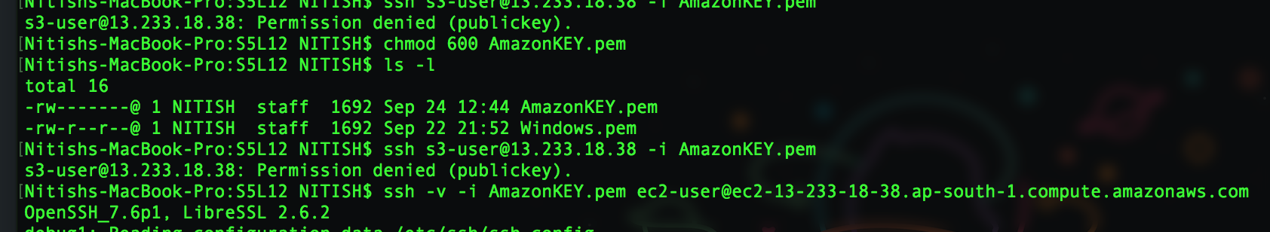

chmod 600 AmazonKEY.pem

ssh -v -i AmazonKEY.pem ec2-user@ec2-13-233-18-38.ap-south-1.compute.amazonaws.com

service httpd status
service httpd start
yum install httpd -y

chkconfig httpd on It will make sure that httpd service start, every time you restart your ec2 instance

cd /var/www/html/
nano index.html

<html><h1>Hello Cloud Guru</h1></html>

Press Control+x and Y to save the file

Nano heathcheck.html

Q. What is the difference between CloudTrail and CloudWatch?
Ans. Cloud watch is for logging, monitoring. Eg. CpuUtillization. Whereas Cloud Trail is for auditing. It will monitor entire AWS environment. Like if you create a new user , new role, new S3 bucket that will be logged through CloudTrail.

S5-L14 AWS CLI LAB

Configure the AWS User ID
[root@ip-172-31-5-157 ec2-user]# aws configure
AWS Access Key ID [None]:
AWS Secret Access Key [None]:

Default region name [None]: ap-south-1
Default output format [None]:

Shut Down the AWS Instance through AWS CLI
cd ~
cd .aws
ls
nano credentials
aws ec2 describe-instances
i-0c60bacbb5b5b0d2a
aws ec2 terminate-instances --intance-ids i-0c60bacbb5b5b0d2a

S5-L15 IAM ROLES LAB

IAM > ROLES > Create New Role >Select Amazon EC2 > Select AmazonS3FullAccess > RoleName S3-Admin-Access

Create Amazon Linux AMI EC2 instance > Select IAM Role as S3-Admin-Access, Rest will be default.

We can Attach/Replace IAM role to an EC2 instance by Action > Instance Setting > Attach/Replace IAM Role.

ssh -v -i AmazonKEY.pem ec2-user@ec2-13-233-106-133.ap-south-1.compute.amazonaws.com

sudo su

aws s3 ls

cd ~

cd .aws >> ERROR- No such file

aws configure
AWS ACCESS KEY ID:

AWS SECRET ACCESS KEY:

DEFAULT REGION NAME: ap-south-1
DEFAULT OUTPUT FORMAT:

cd .aws

nano config

S5-L16 CLI AND REGIONS

Create Amazon Linux AMI EC2 instance > All settings will be default.

S3> Create s3 buckets “acloudguru-nv (Region as London)” “acloudguru-useast1 (Region as US East)” “acloudguru-euwest2 (Region as EU London)” “acloudguru-apsoutheast2 (Region as Asia Pacific Sydney)”

Upload acloudguru-apsoutheast2 Add cowboys.jpg

Upload acloudguru-euwest2 Add pool.jpg

Upload acloudguru-useast1 ACG-Austin.jpg

IAM > Roles> Create new Role>Select Amazon EC2 > Select AmazonS3FullAccess > RoleName MyS3AdminAccess

ssh -v -i AmazonKEY.pem ec2-user@ec2-11-111-111-11.ap-south-1.compute.amazonaws.com

sudo su

aws s3 ls >> Unable to locate credential

We can Attach/Replace IAM role to an EC2 instance by Action > Instance Setting > Attach/Replace IAM Role > Select MyS3AdminAccess from dropdown menu > Apply

Wait for few seconds to sync in case you are getting error

aws s3 ls

aws s3 cp --recursive s3://acloudguru-useast1 /home/ec2-user

ls (You should see the ACG-Austin.jpg file copied to your ec2 instance)

aws s3 cp --recursive s3://acloudguru-euwest2 /home/ec2-user (ERROR as region is not provided)

aws s3 cp --recursive s3://acloudguru-useast1 /home/ec2-user --region eu-west-2

ls (You should be able to see pool.jpg file as well as ACG-Austin.jpg file)

aws s3 cp --recursive s3://acloudguru-apsoutheast2 /home/ec2-user

S5-L17 BASH SCRIPTING LAB (Bootstrap Script)

Create a simple html as shown below in text file and save it as index.html

<html><body><h1>Hello Cloud Gurus!!</h1></body></html>

CHANGE YOUR REGION TO US EAST (N VARIGINIA)

Create an S3 bucket

Bucket Name- mywebsitebucket-acloudguru
Region- US standard

Upload the index.html file which you created.

Create IAM Role

Role name- MyS3AdminAccess > Select Amazon EC2 > Select AmazonS3FullAccess

Create Amazon Linux AMI EC2 instance
- IAM Role - MyS3AdminAccess
- Under Advance details> Select text under User data and provide below code

#!/bin/bash
yum update -y
- Create Security group
- Create a new Key Pair

Open terminal and locate the location where you downloaded the KeyPair.
chmod 400 MyNVKeyPair.pem

ssh -v -i MyNVKeyPair.pem ec2-user@ec2-11-111-111-11.ap-south-1.compute.amazonaws.com

yum update -y
yum install httpd -y
service httpd start
chkconfig httpd on

cd /var/www/html
aws s3 cp s3://mywebsitebucket-acloudguru/index.html /var/www/html
In case of v4 error- Provide --region and the name of the region in which ec2 instance is
Ls (You should be able to see the index.html file)
service httpd status

What we did here in the lab step by step can be done at a time. Follow below section to perform the same.

Create Amazon Linux AMI EC2 instance
- IAM Role - MyS3AdminAccess
- Under Advance details> Select text under User data and provide below code

#!/bin/bash
yum update -y
yum install httpd -y
service httpd start
chkconfig httpd on
aws s3 cp s3://mywebsitebucket-acloudguru/index.html /var/www/html

Copy the IP Public ID and open it in the browser. You should be able to see your website.
If not able to see ipAddress/index.html

S5-L18 Instance Metadata

Create Amazon Linux AMI EC2 instance
- IAM Role - MyS3AdminAccess
- Under Advance details> Select text under User data and provide below code

#!/bin/bash
cd /var
echo “Hello Cloud Guru” >> HelloGurus.html

ssh -v -i MyNVKeyPair.pem ec2-user@ec2-11-111-111-11.ap-south-1.compute.amazonaws.com

sudo su

To get the metadata, run below command- it will return different variables

curl http://169.254.169.254/latest/meta-data/

e.g. To get public ip address, run below command

curl http://169.254.169.254/latest/meta-data/public-ipv4

We can also write the output in the file,

curl http://169.254.169.254/latest/meta-data/public-ipv4 > mypublicIP.html

To Check,

nano mypublicIP.html

You can see the Bootstrap script you added earlier when you initiated the EC2 instance
curl http://169.254.169.254/latest/user-data/

S5-L19 Launch Configuration & Auto Scaling Groups

Create a file called healthcheck.html with below text,
I am healthy.

S3> Open the acloudguruwebsitebucket
Index.html should be there, Also upload the healthcheck.html file which you created.

Goto EC2> Load Balancer and check if it is configured.

Under the AutoScaling > Launch Configurations > Create AutoScaling group > Create Launch Configuration > Select Amazon Linux AMI EC2 instance > Under Configuration Details provide below info

Name MyAutoScalingGroup
IAM Role S3AdminAccess
Under Advance details> Select text under User data and provide below code
#!/bin/bash
yum update -y
yum install httpd -y
service httpd start
chkconfig httpd on
aws s3 cp s3://mywebsitebucket-acloudguru /var/www/html --recursive

Create launch configuration >

Group Name- MyAutoScalingGroup
Group Size- 3
Subnet- Select all the Availablity Zone within the region as the basic idea is to have back up of your data in all AZ.

So- 3 Group Size will be distributed among the AZ you selected under Subnet

Under ADVANCE DETAILS, Provide below info-

Check the radio button for Load Balancing and select the MyWebDMZ Load Balancer.

HealthCheck Type- ELB
HeathCheckGracePeriod – 150

Next>Configure Scaling Policies > Check the “Keep the group in its initial state”> Next

(Check the radio button for “Use Scaling Policies to adjust the capacity of this group”

Scale between 1 and 5

Execute policy when > Add new alarm
Uncheck the Send Notification and provide values as >= 90 and then Click on Create Alarm.

Take the Action – 1 instances
Instances need- 300

Similar, you can set the value to DECREASE GROUP SIZE in case your CPU utilization decreases.)

Configure Notification >
Send a notification to : SysAdminTeam
With these recipients: something@gmail.com

Configure Tags >
Key- StaffID, Department
Value- 123456, Test&Dev

Review> Create Auto Scaling Group

IT will launch 3 instances in different AZ with the data in each instance. You can verify it by copying the public ip address and fire it on different browser tabs.

The other thing which we can do is to go to Load Balancer and grab the DNS name and open it in browser, You should be able to see the data.

Finally- Delete the AutoScaling Group.

S5-L21 EFS Lab

What is EFS?

Amazon Elastic File System (Amazon EFS) is a file storage service for Amazon Elastic Compute Cloud (Amazon EC2) instances.

It is easy to use and provide a simple interface that allows you to create and configure file systems quickly and easy. With Amazon EFS, Storage capacity is elastic, growing and shrinking automatically as you add and remove files, so your applications have the storage they need, when they need it.

Console>Storage>EFS> Select the supported region if getting error

Create file System > Configure File system access

VPC- default
Create Mount target> Select all AZ > Next

Add Tags>
Name- MyEFSFileSystem

Review and Create the EFS.
Create Amazon Linux AMI EC2 instance
- Subnet – Select the subnet (based on the region you selected).

Create One more Amazon Linux AMI EC2 instance
- Subnet – Select the subnet (based on the region you selected, select different subnet).

Create a Load Balancer

Load Balancer > Create Load Balancer > Load Balancer Name(MyProdLB) / Configure HealthCheck(5 10 2 3) > Add both EC2 instances > Create

Make sure both the instances have same security group.(Edit both instances and add the default security group as well bcz the EFS belong to default security group)

Open 2 different terminals.

Login to both the instances and follow below command

ssh -v -i MyNVKeyPair.pem ec2-user@ec2-11-111-111-11.ap-south-1.compute.amazonaws.com

Sudo su

Yum install httpd -y

Service httpd start

cd . (In both terminal)

EFS> Select the EFS > EC2 mount instructions > Copy the mount instructions (sudo mount ..) and run the command in both terminal. (replace the target directory i.e. efs with /var/www/html)

cd /var/www/html

nano index.html > Hello Cloud Guru

Check the index.html file from another terminal in /var/www/html location !!

EC2 > Load Balancer > Instances > can check the heathcheck there !!

You can also check the DNS name in browser.

S5-L23 Lambda Concept

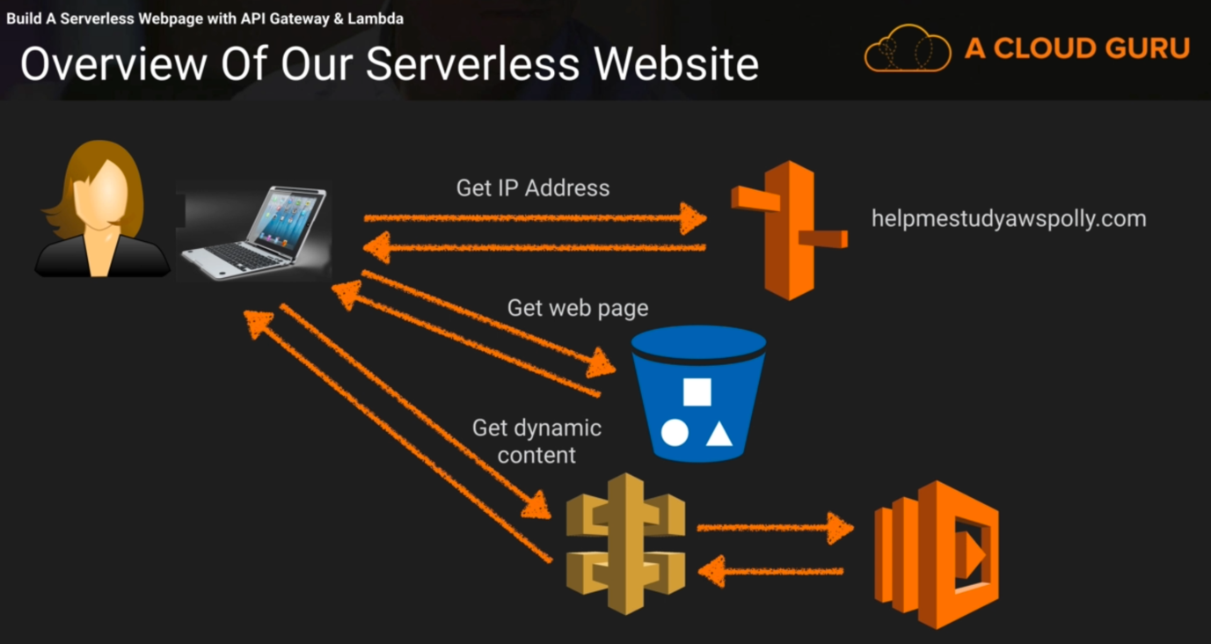

Download the code from Udemy.

Things to remember

Bucket name and domain name should be same.

S3> Create bucket with unique name e.g. helpmestudyawspolly.com/ Region- N. Verginia > Create > Property > Static Website Hosting Index.html/ error.html > Save

Console > Networking & Content Delivery Route 53 > Choose a domain name > & Checkout

Compute > Lambda > Create Function > Author from Scratch > Name- myServerlessWebsite / RunTime-Python 3.6 / Role- Create a new role- MyLambdaRole / Policy Template- Simple Microservice Permission > Create Function.

Select API Gateway > Configure triggers > Create a new API > API Name myServerlessWebsite / Deployment stage Prod / Security Open > Add > SAVE

Under API Gateway > myServerlessWebsite > Action > Delete Method > Delete

Action > Create Method > Select GET from drop down > Check the radio button for “Use Lambda Proxy Integration” > Lambda Function myServerlessWebsite > Saves

Action > Deploy API > Deployment stage prod > Description My first prod deployment > Deploy
Stages > Prod > GET > Copy and open the “Invoke URL”.

IN EC2 Instance;

curl “Invoke URL” > myname.txt
nano myname.txt

Edit the downloaded index.html file and paste the “invoke URL” in line 11.

S3> helpmestudyawspolly.com > Upload > Add File index.html & error.html > Upload > More > Make Public

Console > Networking & Content Delivery Route 53 > Hosted Zone > helpmestudyawspolly.com > Create Record Set > Alias Target > Select the helpmestudyawspolly.com > Create

S5-L24 Using Polly To Help Your Exam (Part 1)

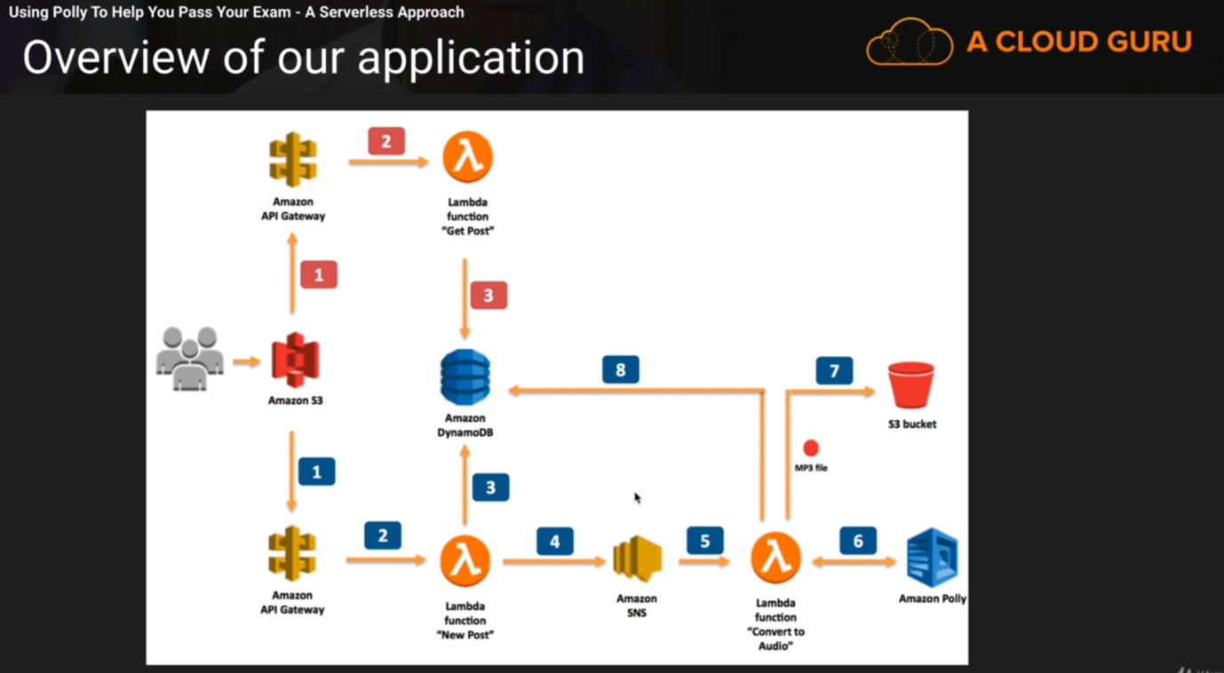

Change the region to N. Virginia

Under Machine Learning > Amazon Polly > Get Started

Console > Database > DynamoDB > Create Table > Table name post / primary key id > Create

Console > S3 > helpmestudyawspolly.com > Delete both files
Create new S3 bucket > Bucket name pollymp3storagebucket > Create
IAM > Roles > Create Role > Lambda > Next > Create Policy > Open the downloaded lambdapolicy.json file and copy the code > JSON > Paste the code > Review Policy > Name myLambdaPollyPolicy / Desc myLambdaPollyPolicy > Create

IAM > Roles > Create Role > Lambda > Next > search & select myLambdaPollyPolicy > Next > myLambdaPollyRole (in desc as well) > Create

Console > S3 > helpmestudyawspolly.com > Permission > Bucket Policy > Open the downloaded bucketpolicypermission.json file and copy the code > Paste and update the arn value, ARN value is highlighted next to Bucket Policy Editor > Save

Console > Application Integration > Simple Notification Service > Create Topic > Name new_post / Display Name SNSPolly > Create

Console > Lambda > Create Function > Name PostReader_NewPost / Runtime Python 2.7 / Existing Role myLambdaPollyRole > Create Function > Open the downloaded newposts.py file and copy the code > Paste the code in the IDE > Save > Under Environment Variable > key DB_TABLE_NAME / value posts / key SNS_TOPIC / value (Console > Simple Notification Service > Topics >Copy the ARN value of new_posts) paste the copied ARN value. > Basic Settings > Description This function insert data in to Dynamo DB > SAVE > Test > Event Name HelloJoanna > Open the downloaded sample.json file and copy the code > Paste the code in the editor > Create > Test

Verify it !!

Console > DynamoDB > Tables > posts > item > You can see the items provided in the editor

WHERE IS LAMBDA LOCATED
ITS LOCATED UNDER COMPUTE SECTION.

S5-L25 Using Polly To Help Your Exam (Part 2)

Console > Lambda > Create Function > Name PostReader_ConvertToAudio / Runtime Python 2.7 / Existing Role myLambdaPollyRole > Create > Open the downloaded converttoaudio.py file and copy the code > Paste the code in the IDE > Save > Environment Variable > Key DB_TABLE_NAME / Value posts / Key BUCKET_NAME / Value pollymp3storagebucket > Save > Basic Settings > Description This function generates MP3 and stores them in S3 / Timeout 5 mins > Save > Under Configuration select SNS > Configuration Requied > Under Configure trigger > SNS Topic new_posts > Add > SAVE

Console > Lambda > Create Function > Name PostReader_PostReader_GetPosts / Runtime Python 2.7 / Existing Role myLambdaPollyRole > Create > Open the downloaded getposts.py file and copy the code > Paste the code in the IDE > Save > Environment Variable > Key DB_TABLE_NAME / Value posts > Save
Test > Event Name GetPosts > paste the below code > Create > Test
{
“postId” : “*”
}

Console > API Gateway > Create API > API Name PostReaderAPI/ Desc My API for Polly > Create > Create Method > GET > Lambda Function PostReader_GetPosts > Save
Create Method > POST > Lambda Function PostReader_NewPosts > Save
Select ‘/’ before further action Actions > Enable CORS > Enable CORS > Yes, Replce Existing Value.
Get > Method Request> URL Querry String Parameters > Add Querry String > Name postId > click on tick icon

Get > Integration Request> Body Mapping Templates > Select When there are no… > Add mapping templates application/json > Tick > Click on the application/json > Open the downloaded mappings.json file and copy the code > Paste in the Editor > Save

Select ‘/’ before further action Actions > Deploy API > Deployment stage New Stage / Stage Name prod in all 3 places > Deploy > Copy the invoke URL > Open the downloaded scripts.js file and replace the invoke URL in line 1 > Save it.

S3> helpmestudyawspolly.com > Add files > scripts.js / index.html / styles.css > Upload > index.html > Click on the Overview -> Link > Link > Type * and click on Search

Console > DynamoDB > Table > posts > items > Select item > Action > Delete

Open the URL helpmestudyawspolly.com in browser and you should be able to see the website > Put any text in the space and click on say it > Type * and click on Search > You should be able to see the player and other options.

SECTION 6

S6-L2 Route-53-Register-A-Domain-Name-Lab

Console> Networking & Content Delivery > Route 53 > Get Started Now > (Notice region is Global) > Registered Domain > Register Domain > helloroute53gurus.com > Check > Continue > Checkout

